ACADEMIA INTERNACIONAL DE DAVID


TECHNOLOGY
SUMMATIVE WORKSHOP # 2

NAME: __________________________ DATE: _______________________ 3rd ^{Grade}: A B C
TEACHER: EDGAR PITTY
INSTRUCTIONS: READ THE WORKSHOP CAREFULLY. DO NOT USE PEN. DOUBLE ANSWERS OR CROSS OUTS ARE NOT VALID. RETURN THE ASSIGNMENT AFTER YOU FINISH OR BEFORE THE END OF THE CLASS.
Name and date: 2 pts. |  | Follow Instructions: 2 pts.
Order: 2 pts. |  | Correct use of tools: 2 pts.
Punctuality: 2 pts.
CONTENT: 30 pts. |  | TOTAL: 40 pts.

Part I: Identify the part of the robot with the correct name. Check your spelling on each question. 2 pts. each 10 pts. total.

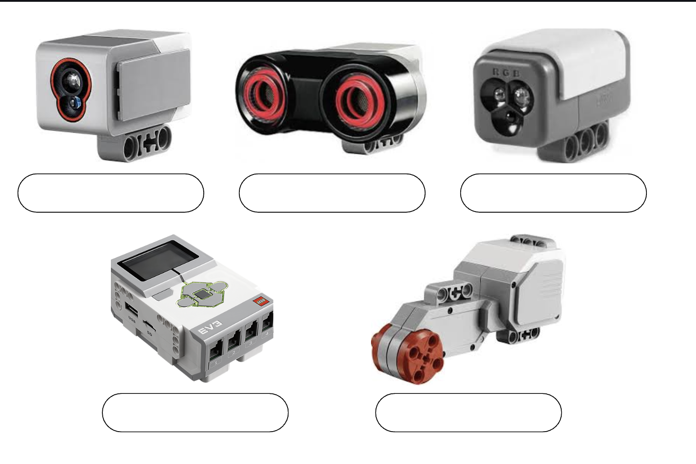

Part II: Choose with a circle the correct answer based on the function of the part of the robot. 2pts each, 10 pts. total.
Choose the correct answer.

- What does a sensor do?
  - a) Moves the robot.
  - b) Detects information from the environment.
  - c) Stores energy.
- What is the function of a motor?
  - a) Makes the robot move.
  - b) Detects light.
  - c) Controls decisions.
- What does the controller (brain) do?
  - a) Gives energy.
  - b) Makes decisions and controls the robot.
  - c) Helps the robot move.
- What is the function of a battery?
  - a) Detects obstacles.
  - b) Gives energy to the robot.
  - c) Controls movement.
- What do wheels do?
  - a) Store energy.
  - b) Help the robot move from one place to another.
  - c) Detect sound.

Part III. Choose with a circle the best answer. Every question represents a situation, choose the best option to help the robot complete the task. 2 pts. each, 10 pts. total.

- If a robot needs to move from one place to another, what part should it use?
a) Wheels
b) Controller
c) Sensor
- If a robot needs energy to function, what part should it use?
a) Sensor
b) Battery
c) Motor
- If a robot needs to make decisions, what part should it use?
a) Battery
b) Controller (brain)
c) Wheels
- If a robot needs to detect information from the environment, what part should it use?
a) Motor
b) Sensor
c) Battery
- If a robot needs to move, what part should it use?
a) Motor
b) Sensor
c) Controller

